Name: Callejo, Jaff Raine Jay
Year and Section: 2-A
Subject: Platform Technologies
Lab Activity: Cross-Platform OS Administration and Security
Task Description | Screenshot/Output | Notes/Explanation
Task 1 – User Accounts | 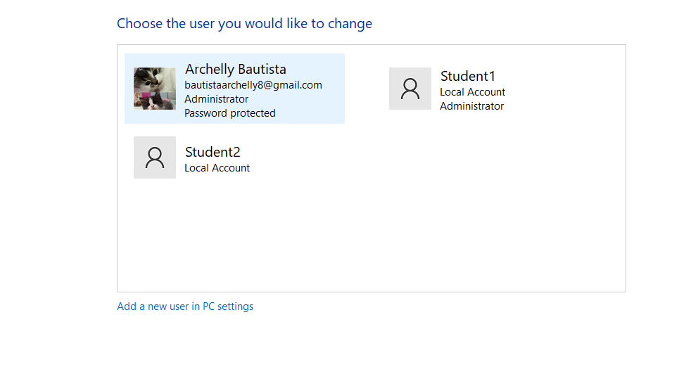 | - I Create a 2 users and I create of Student1 is admin and the Student 2 is User
Task 2 – File/Folder Permissions | …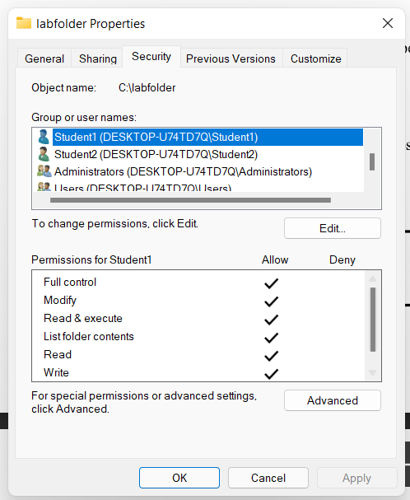  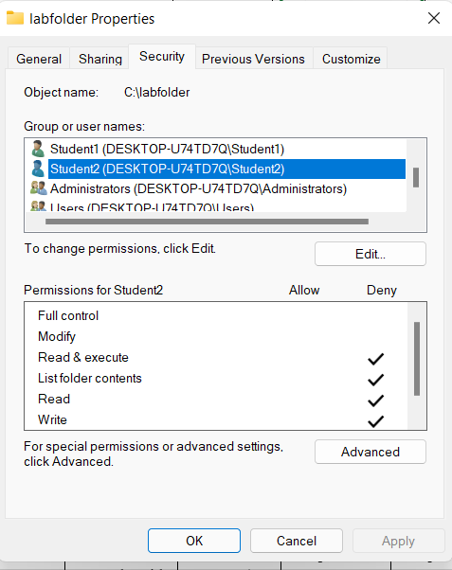 | - I set the permissions of Student 1 in Allow all and the Student 2 is Denied
Task 3 – System Services | … | - Started and Enabled of Print Spooler in Windows
Task 4 – Security Measure | …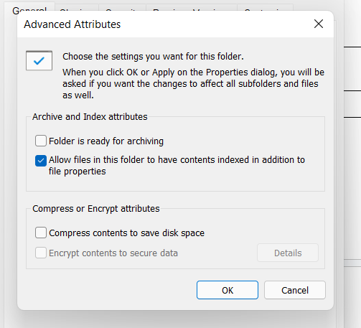 | - I cant Enable it because the Edition is Home Single Language in WIndows 11

Rubric
Criteria | Excellent (20) | Good (15) | Satisfactory (10) | Needs Improvement (5) | Score
User Account Management | Both users created correctly with correct permissions | Minor errors in accounts/permissions | Partial completion | Not completed
File/Folder Permissions | Correct permissions set and tested | Minor mistakes | Partial setup | Not done
System Service Management | Service configured and running correctly | Minor errors, service runs | Partial setup | Not done or fails
Security Measure Implementation | Security applied correctly and verified | Minor mistakes | Partial attempt | Not done
Documentation & Screenshots | Complete, clear, and well-explained | Mostly complete | Partial | Missing or unclear

